CHAPTER 4
DATA ANALYSIS AND INTERPRETATION

Data analysis is the process of systematically applying statistical and logical techniques to describe, summarize, and evaluate data. Analysis and interpretation help in converting raw data into meaningful information. In this study, data collected from employees through a structured questionnaire were classified, tabulated, and analyzed using appropriate statistical tools. The results are presented in the form of tables and diagrams for better understanding.

TOOLS USED FOR DATA ANALYSIS
1. PERCENTAGE ANALYSIS
Percentage analysis is one of the simplest and most widely used statistical tools. It is used to express data in percentage form for easy comparison. The formula used:
Percentage = (Number of Respondents / Total Respondents) × 100
This method helps in understanding the proportion of respondents in each category.

2. BAR CHART
A bar chart is a graphical representation of categorical data using rectangular bars. The height or length of each bar represents the value of each category. It helps in easy comparison between different groups.

3. PIE CHART
A pie chart is a circular diagram divided into slices to represent numerical proportions. Each slice shows the percentage share of each category. It helps in understanding the overall distribution of responses.

TABLE 4.1
AGE OF THE RESPONDENTS
Age Group | Number of Respondents | Percentage
18–25 years | 22 | 22%
26–35 years | 38 | 38%
36–45 years | 25 | 25%
Above 45 years | 15 | 15%
Total | 100 | 100%

FIGURE4.1
AGE OF THE RESPONDENTS
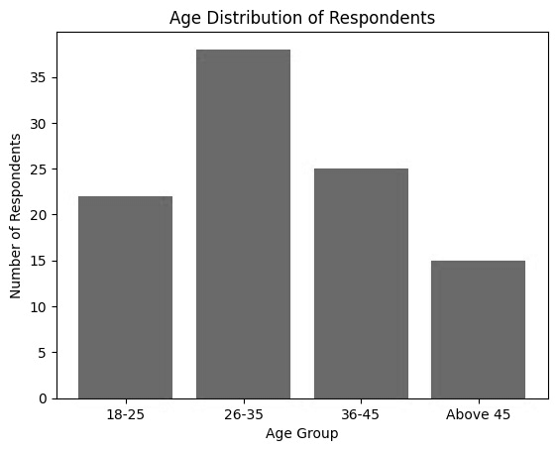
INTERPRETATION
The above table shows that majority (38%) of employees belong to the age group 26–35 years. This indicates that the organization has a young and active workforce.
TABLE4.2
SHOWING THE GENDER OF THE RESPONDENTS
Gender | Number of Respondents | Percentage
Male | 72 | 72%
Female | 26 | 26%
Other | 2 | 2%
Total | 100 | 100%

FIGURE 4.2
SHOWING THE GENDER OF THE RESPONDENTS
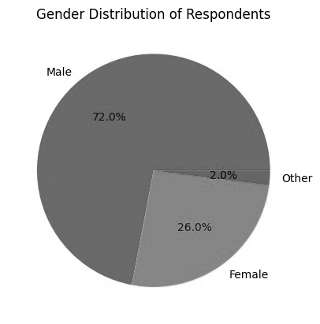
INTERPRETATION
The majority of respondents (72%) are male employees, indicating male dominance in the workforce.
TABLE 4.3
Department | Number | Percentage
Production | 40 | 40%
Maintenance | 20 | 20%
Quality Assurance | 15 | 15%
Administration | 15 | 15%
Management | 10 | 10%
Total | 100 | 100%
SHOWING THE DEPARTMENT

FIGURE 4.3
SHOWING THE DEPARTMENT
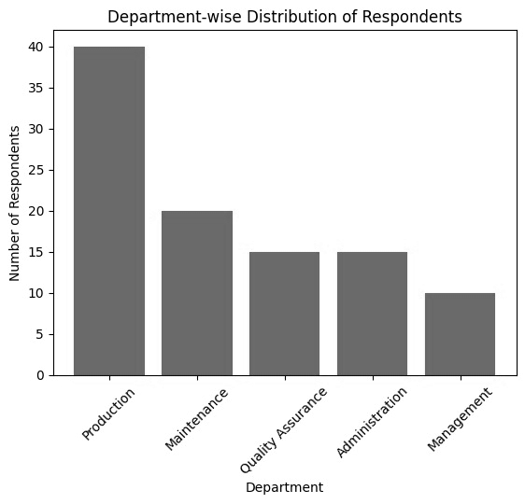
INTERPRETATION
Most respondents (40%) belong to the production department, which involves higher exposure to workplace hazards.
TABLE 4.4
SHOWING AWARENESS OF SAFETY POLICIES
Response | Number | Percentage
Yes | 82 | 82%
No | 8 | 8%
Partially | 10 | 10%
Total | 100 | 100%

FIGURE 4.4
SHOWING AWARENESS OF SAFETY POLICIES
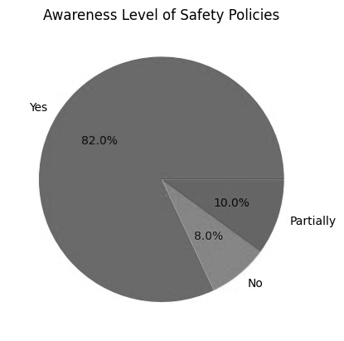

INTERPRETATION
82% of employees are aware of safety policies, showing effective communication of safety procedures.

TABLE 4.5
SHOWING PPE USAGE
Response | Number | Percentage
Always | 60 | 60%
Sometimes | 25 | 25%
Rarely | 10 | 10%
Never | 5 | 5%
Total | 100 | 100%

FIGURE 4.5
BAR CHART SHOWING PPE USAGE
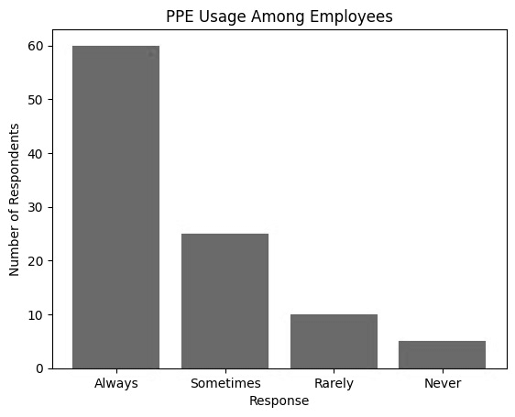

INTERPRETATION
60% of employees always use PPE, while 5% never use it. Strict monitoring is required to improve compliance.
TABLE 4.6
SHOWING EFFECTIVENESS OF SAFETY TRAINING
Rating | Number | Percentage
Excellent | 28 | 28%
Good | 42 | 42%
Fair | 20 | 20%
Poor | 10 | 10%
Total | 100 | 100%

FIGURE 4.6
PIE CHART SHOWING TRAINING EFFECTIVENESS
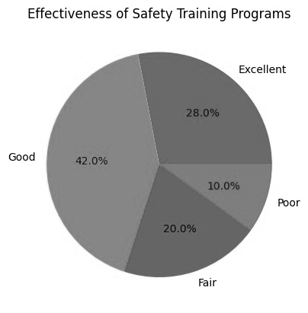

INTERPRETATION
Majority (70%) rated the training as Good or Excellent, indicating satisfactory safety training programs.
TABLE 4.7
SHOWING WORKPLACE ACCIDENT EXPERIENCE
Response | Number | Percentage
Yes | 30 | 30%
No | 70 | 70%
Total | 100 | 100%

FIGURE 4.7
BAR CHART SHOWING ACCIDENT EXPERIENCE
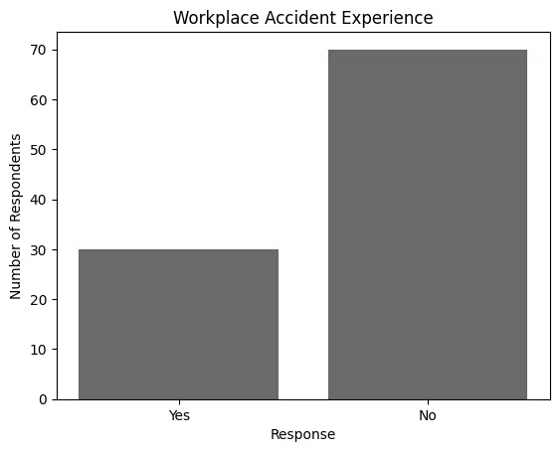

INTERPRETATION
70% of respondents have not experienced workplace accidents, indicating effective safety measures.

